Pulling Hair Social Story
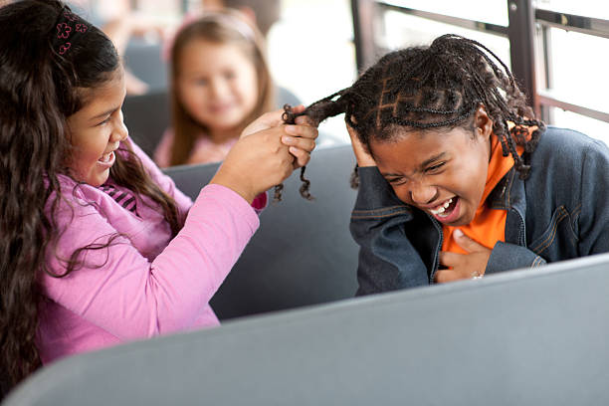
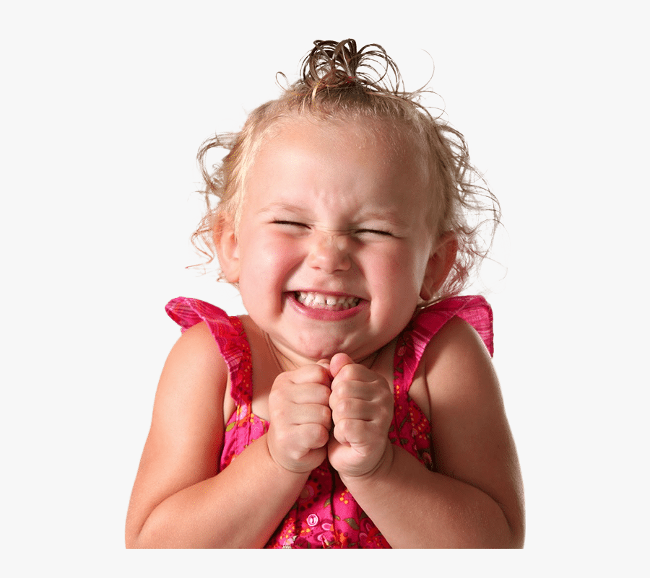
Sometimes when I feel excited…
I may pull my friend’s hair

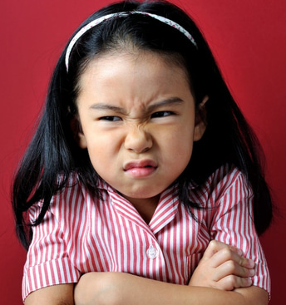
Sometimes when I feel angry…
I may pull my friend’s hair

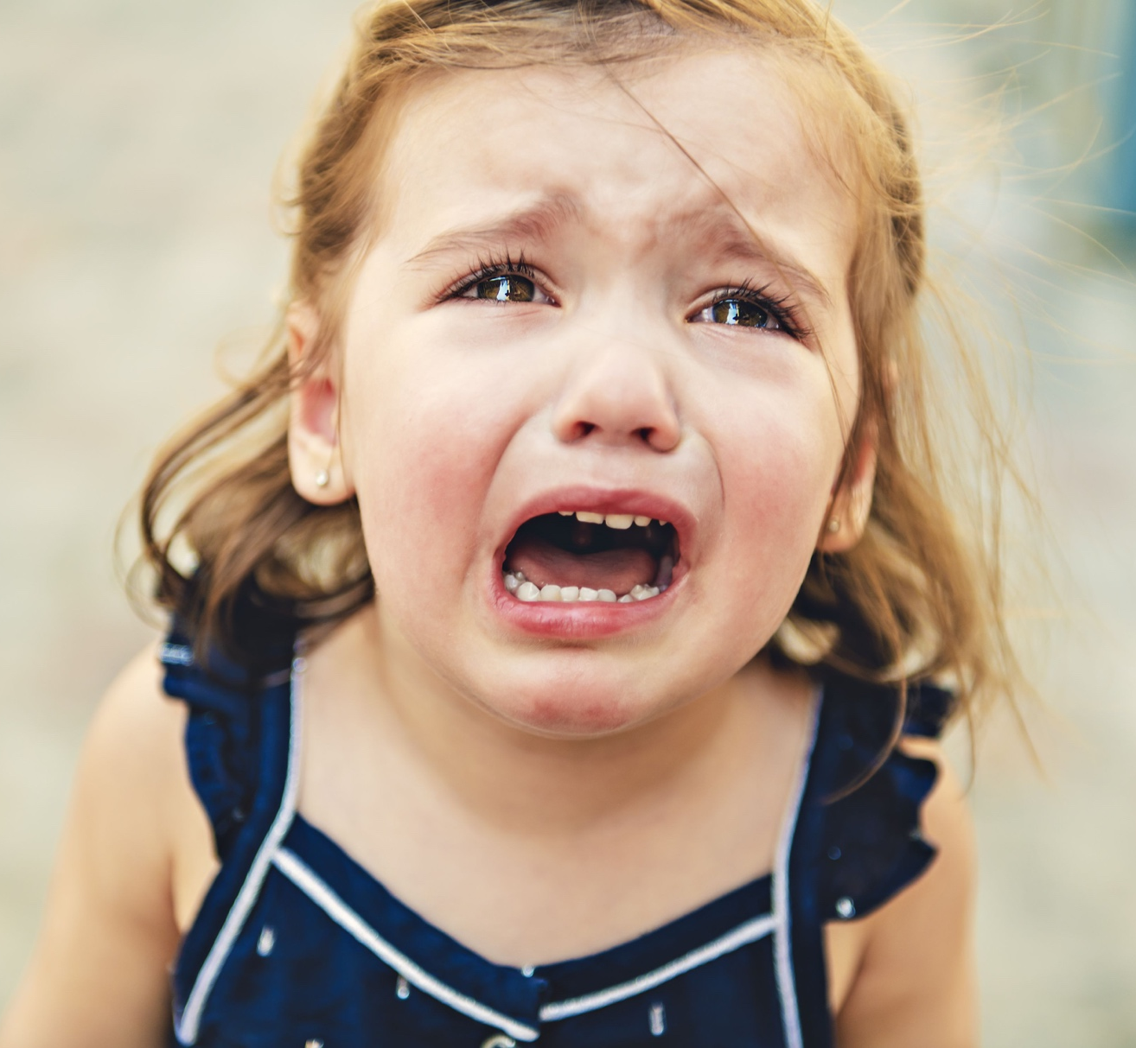
Sometimes when I feel sad…
I may pull my friend’s hair

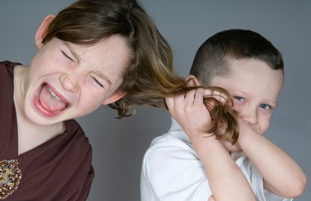

But we should not pull hair

If we pull our friend’s hair, it hurts, and they will be sad.

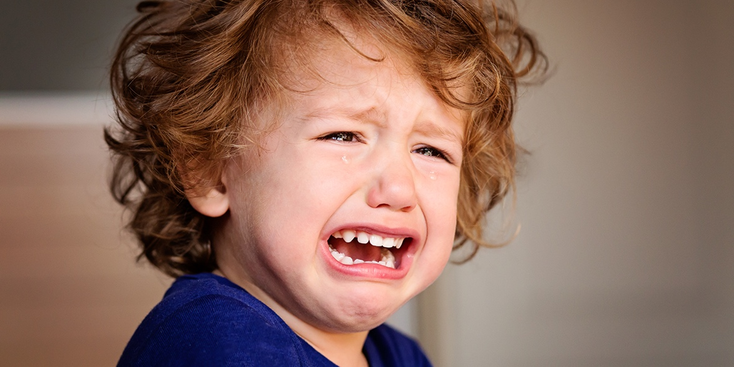

I must remember to keep my hands to myself

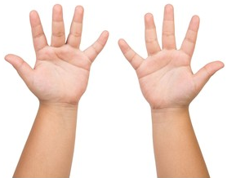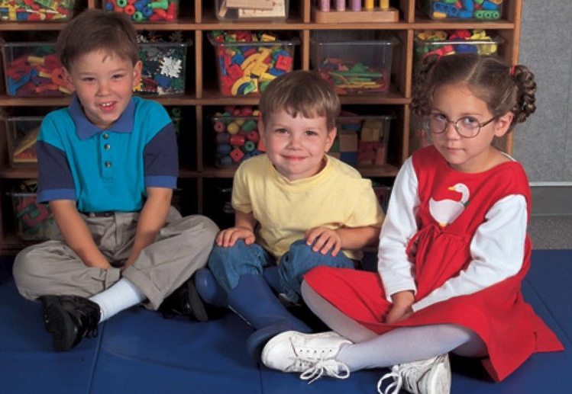

Take a deep breath

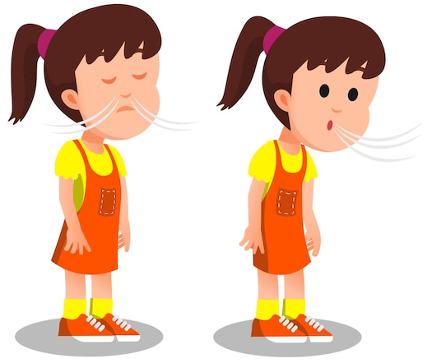
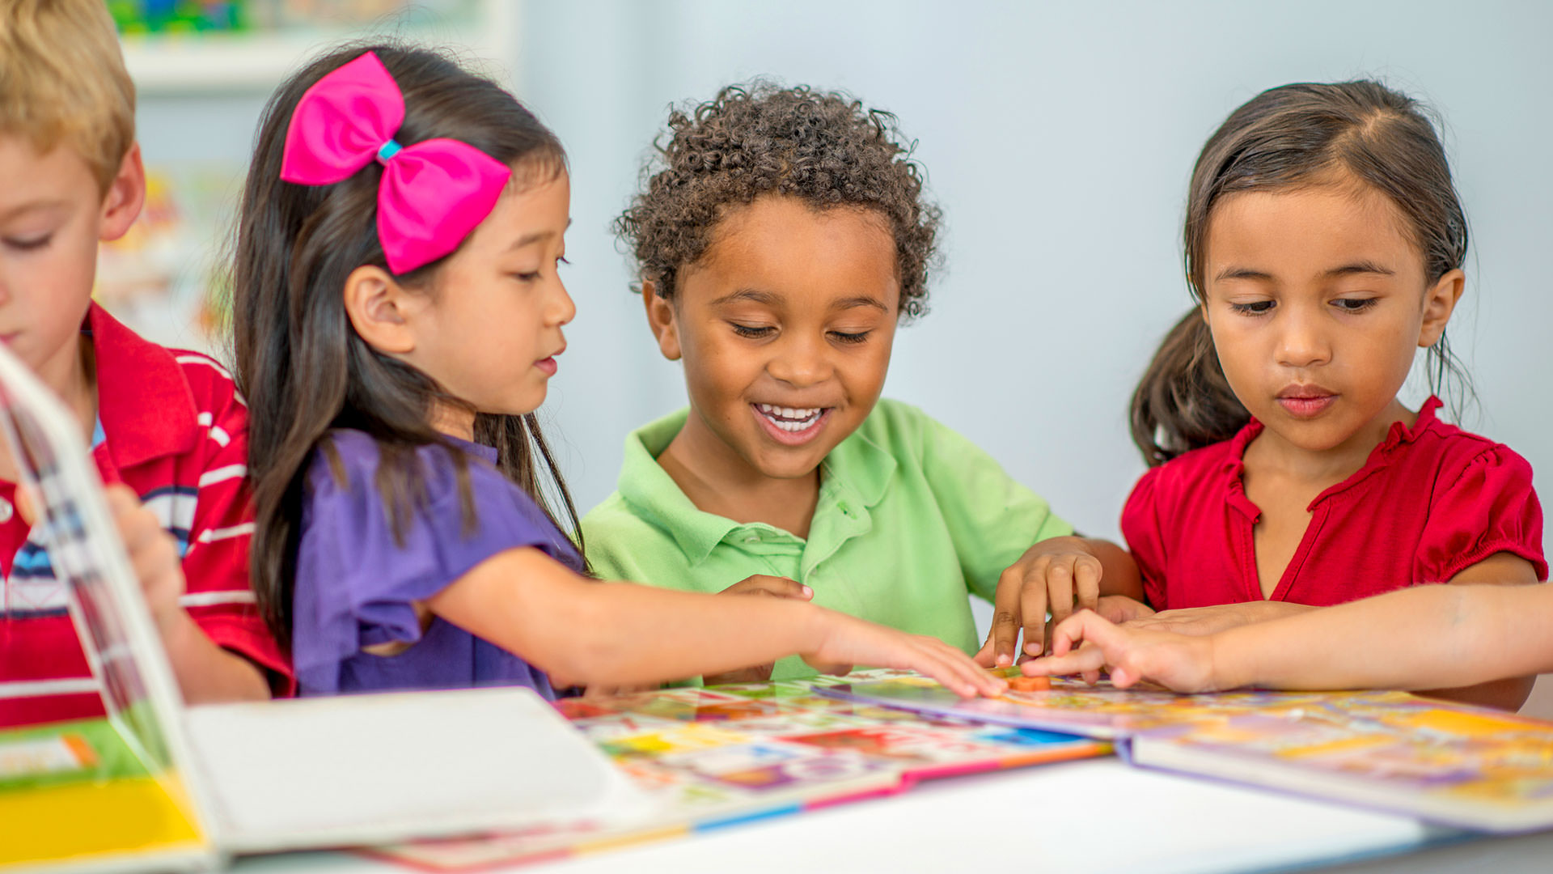

When I do so, we can all be happy and play nicely together.

