My Hands Social Story
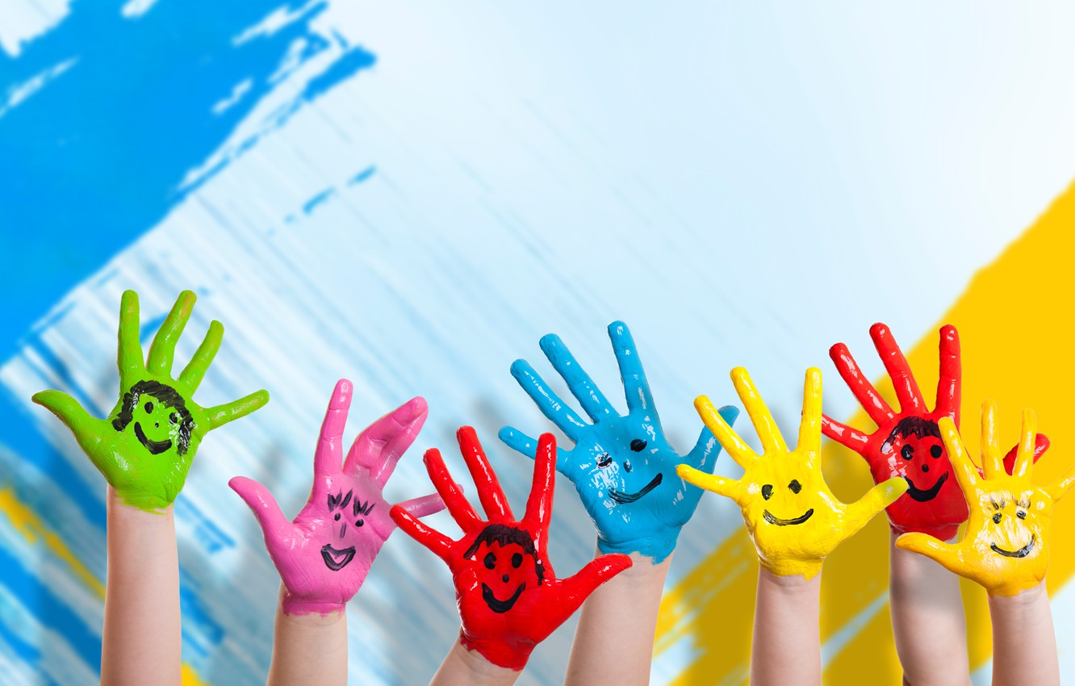

Sometimes I may feel

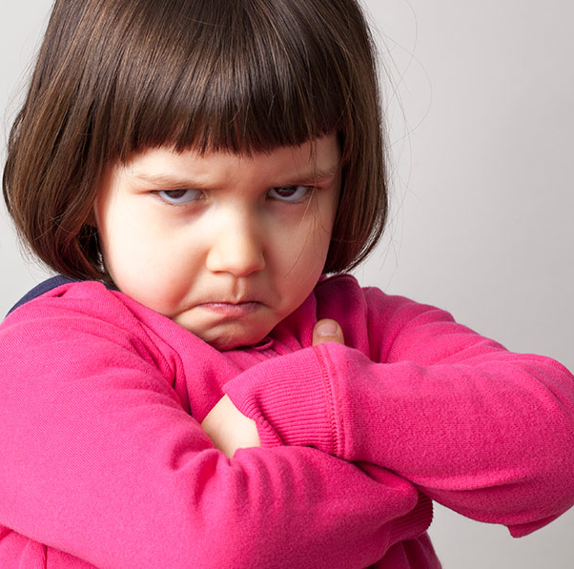
Or
Or
Upset Sad Angry

And I may use my hands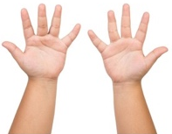 to…

Push
Sometimes I may feel

Or
Or
Upset Sad Angry

And I may use my hands to…
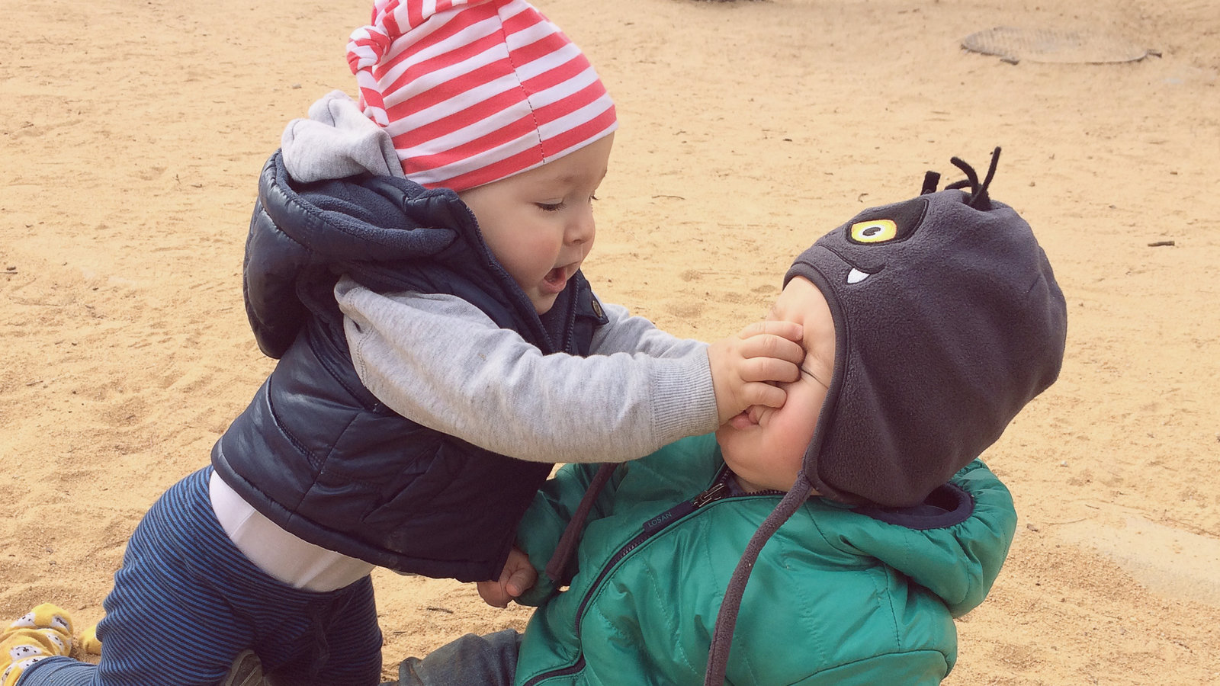
Hit
Sometimes I may feel

Or
Or
Upset Sad Angry

And I may use my hands to…
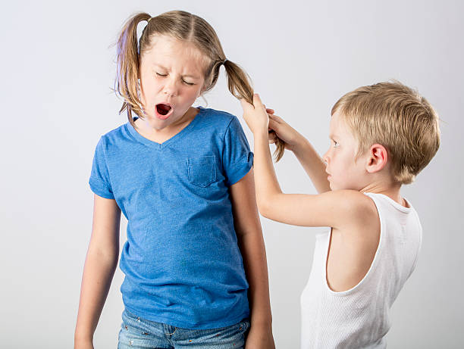
Pull Hair
But when I do, my friends can get hurt and sad
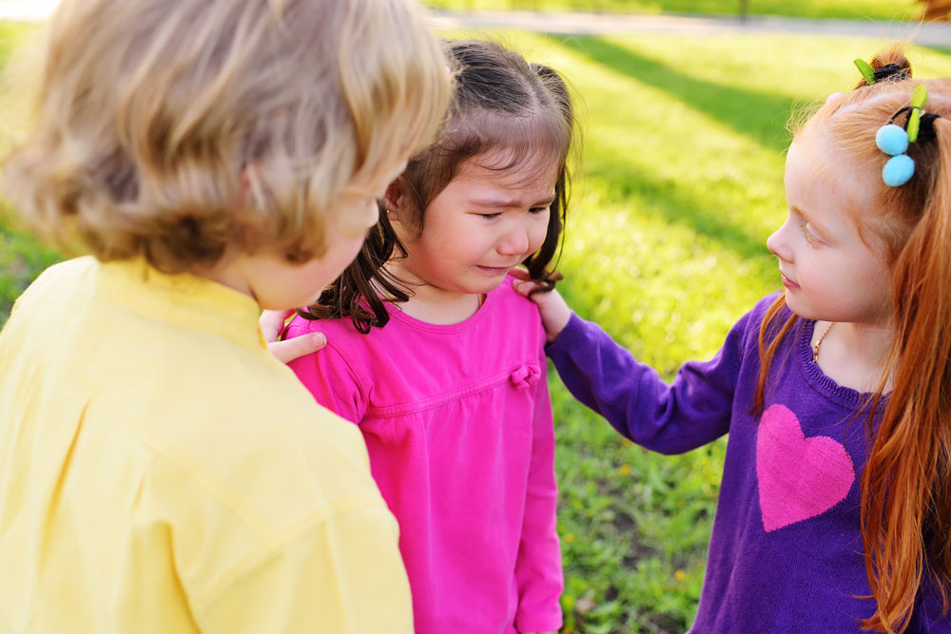

I must remember that my hands are for

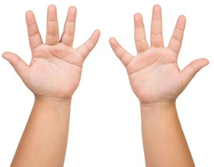
Eating
I must remember that my hands are for

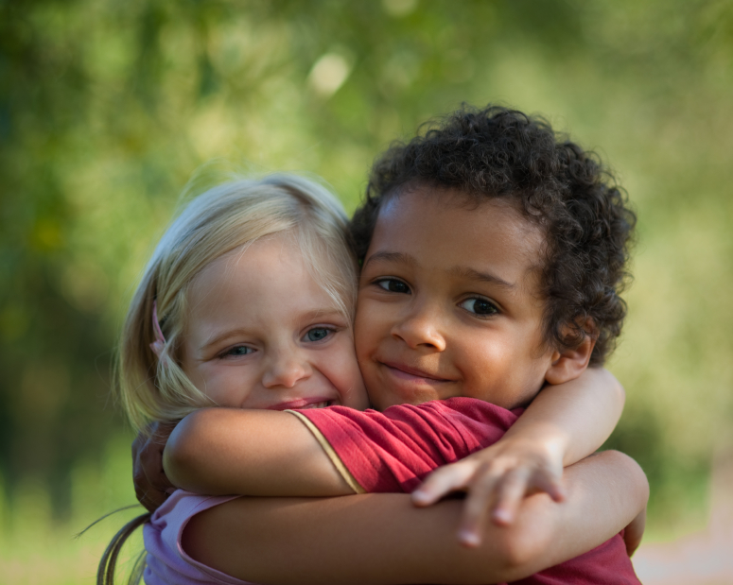

Hugging
I must remember that hands are for

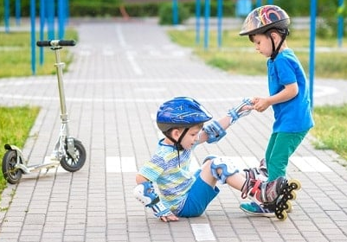

Helping
When I keep my hands to myself, everyone is happy.


